How to do Quantum Power measurements

Radian 22 reference power meter
Detailed info in EURAMET EM-K5 protocol. Manufacturer’s software didn’t worked for me, so one can use SimpleRadianReader:
My power source Fluke 6100 was quite stable on the scale of hours and days, so reading before and after measurement, or even once per day was sufficient (after everything got warmed up).

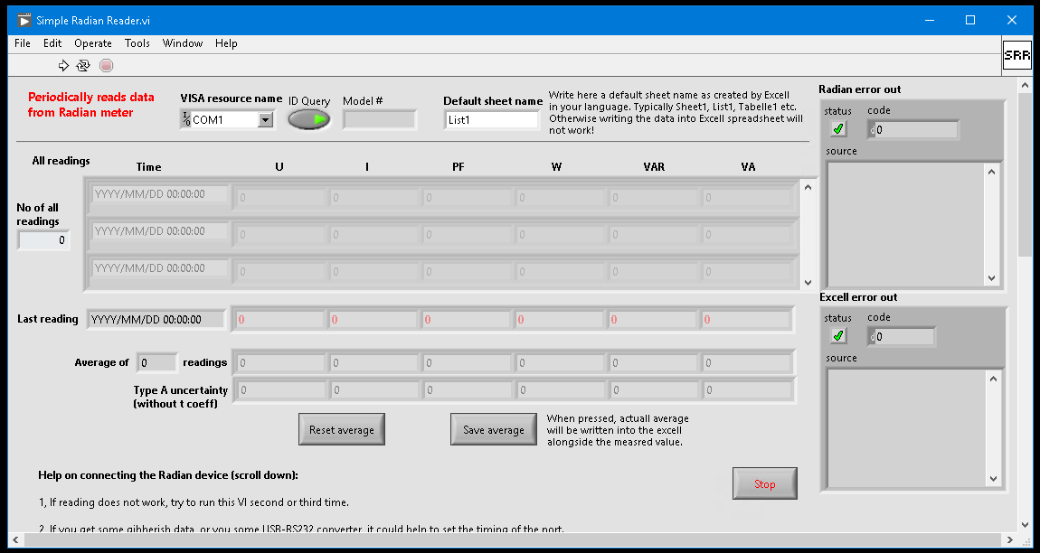
press to save averaged reading
scroll down to get
help in the case of
bad connection
press to run
important!
Thus I had no need to make a simultaneous measurement, this simplified connection setup a lot.
Radian is calibrated only for these values:

I have measured only for 240 V.
ΔP has to be subtracted from value measured by Radian to get the real value.

QuantumPower measurements
The best way to get everything working is to make an Arbitrary Waveform Generator to generate a PJVS function (folder PJVS waveform generator for AWG K3390), e.g. 4 V amplitude and 60 Hz signal and first test all with it, and only if other hardware and software works, start up PJVS.

First start with connecting everything, than using QPMXcontrol and an oscilloscope to test the multiplexer and connections manually. Next go with TWM+QPSCONTROL.

First I made a comparison of PJVS differential method to a QPower method by measuring amplitude of a Fluke 5720A calibrator. Later I have done the power measurement.

Software setup
- Run TWM.
- TWM→ Digitizer: setup digitizer and reference clock.
- TWM→ Digitizer→Config Multiplexer: Set mode ‘switched by external clock’. Set Startup delay according your MX hardware.
- TWM→ Digitizer→Config Multiplexer → Identify.
- TWM→Octave/Matlab: setup GNU Octave paths or Matlab. Press Test QWTB.
- TWM→Setup Measurement: set measurement data files name and path, nothing else is needed.
- TWM→ Server→ Start.
- Run QPSCONTROL.
- If using AWG instead of PJVS, setup AWG manually and in QPSCONTROL→ Setup PJVS → set AC-supraVOLTcontrol, check simulation mode. Otherwise setup your own hardware.
- QPSCONTROL → Setup TWM → Test connection.
- QPSCONTROL → Setup Trigger. Select your trigger hardware, address, test connection.
- QPSCONTROL → Setup Measurement.
- Select scenario.
- Set signal frequency.
- Set maximal amplitude at digitizer – this is used to set PJVS signal amplitude.
- Set sampling frequency.
- Set Record length – at the beginning just use e.g. 3, when everything works use larger numbers.
- Set PJVS frequency, steps per period, PRs/PRe.
- Set MRs and MRe to 1 period.
- Set Timing matrix. If one wants 10 periods of signal, add 1 before and one after to let MX stabilize, thus 12 periods.
- Select correction files. For digitizers only dummy correction file is sufficient. For transducers proper correction files are needed.
- For digitizer a correction file can be generated in QPSCONTROL → Setup TWM → Create correction files…
- Start measurement using Measure button in main window.

If measurement fails from some reason, and you got older version of MX firmware, you have to manually reset the MX (preferably after disconnecting PJVS cables and switching off the source because MX might reset input channels when powering up).

Voltage amplitude measurement

Connection setup
For this I have still used HP 33120 AWG as a trigger source. Worked well in this setup, but not so good in power measurement setup due to grounding issues. Optical isolation on GPIB to the AWG was essential.
Based on the later experience, I should have also tied PJVS Lo cable to Ground, but the results are still good. Maybe because this setup is much simpler than full power measurement.
I have tested influence of using battery for NI5922 digitizer to get it fully floating, no real effect. The big influence was when MX guards were not connected through.
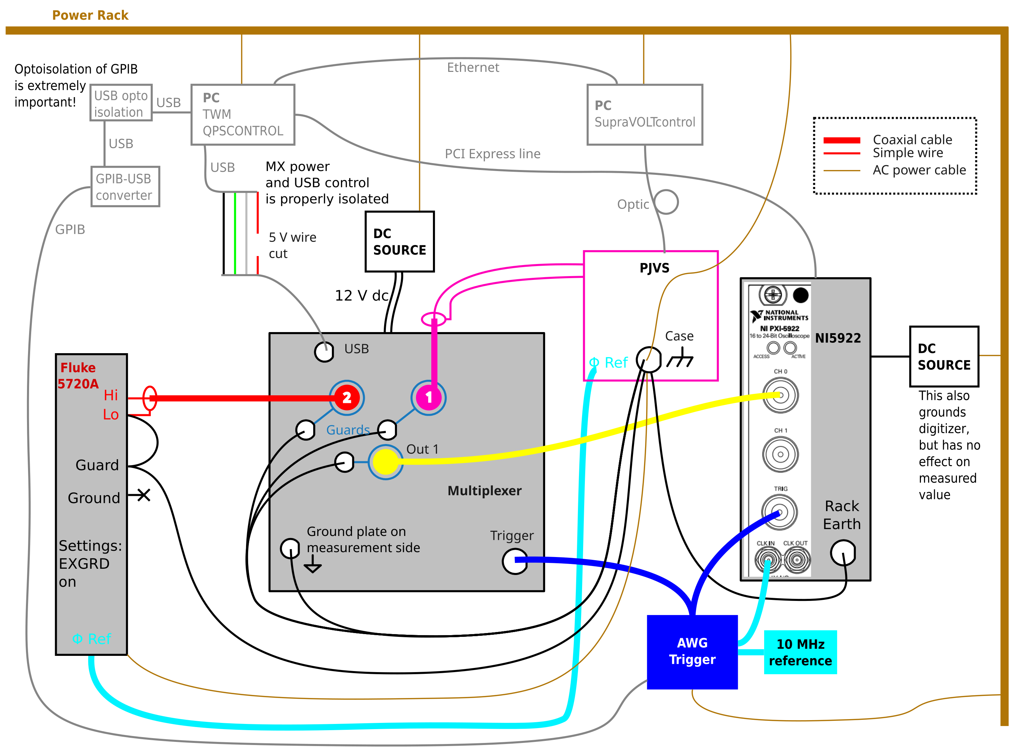

Measurement workflow
Calibrator settings: 0.8 V, 60 Hz, EXGRD on.
10 measurements using supracon software, differential method.
Next QP measurement, scenario 1 signal, 1 ADC 1 PJVS, 12 periods PJVS, 12 periods calibrator signal, repeated 3 times.
Later, when all is tested, increase repetition to e.g. 30 times.

First, check QPSCONTROL→ PJVS setup → Calculate results, and Plot level set to 2. This will produce many plots (measurement data folder). Plots take a lot of time, so for tested setup set it to 0 to speed up measurements.
Generated plots should be check for:
- 00X-00X_pjvs_ident_segments_10.png – shows if MX settled fast. Any MX errors should be before the black vertical line (MRs).
- 001-001_adc_calibration_fit_errors.png – shows digitizer calibration fit errors. Should show some reasonable values.
- 001-001_adc_calibration_fit_errors_time – the same but plotted in time. Should be homogenous.
- 001-001_pjvs_segments_first_period.png – shows PJVS segments. Ringing caused by the digitizer should not be visible (if so, increase PRs, PRe)
- adc_calibration_gains.png – should show reasonable values. My 5922 varied in few uV/V
- demultiplexed.png – should show proper waveforms in proper parts
- signal_amplitudes_sig_001.png – should show correct values of the signal

Expected data
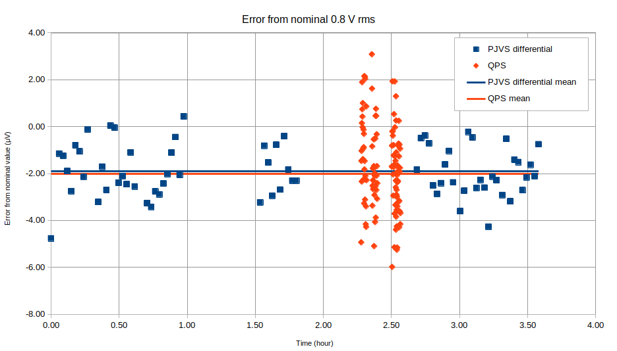

The relative error was 0.3 uV/V (0.1 uV absolute).
QPSW method got greater spread, but measurement is much faster than differential. However speed of differential measurement is given by supracon method, and probably can be optimized.

Power measurement

Connection setup
At the beginning it helps to see waveforms on the oscilloscope. If the grounding is spoiled, the waveforms are quite noisy or distorted. However the oscilloscope itself can cause grounding issues and definitely has to be disconnected in the final setup.
I have used PXI6713 as trigger source. To synchronize digitizer with trigger source a 5 MHz signal was generated by trigger and lead to digitizer.
Thus the system run on 3 different clocks:
- PJVS
- Trigger with digitizer and MX
- Power source
I had to ground the PJVS Lo, otherwise the MX had issues switching. Floating signals seems to be an issue for MX.
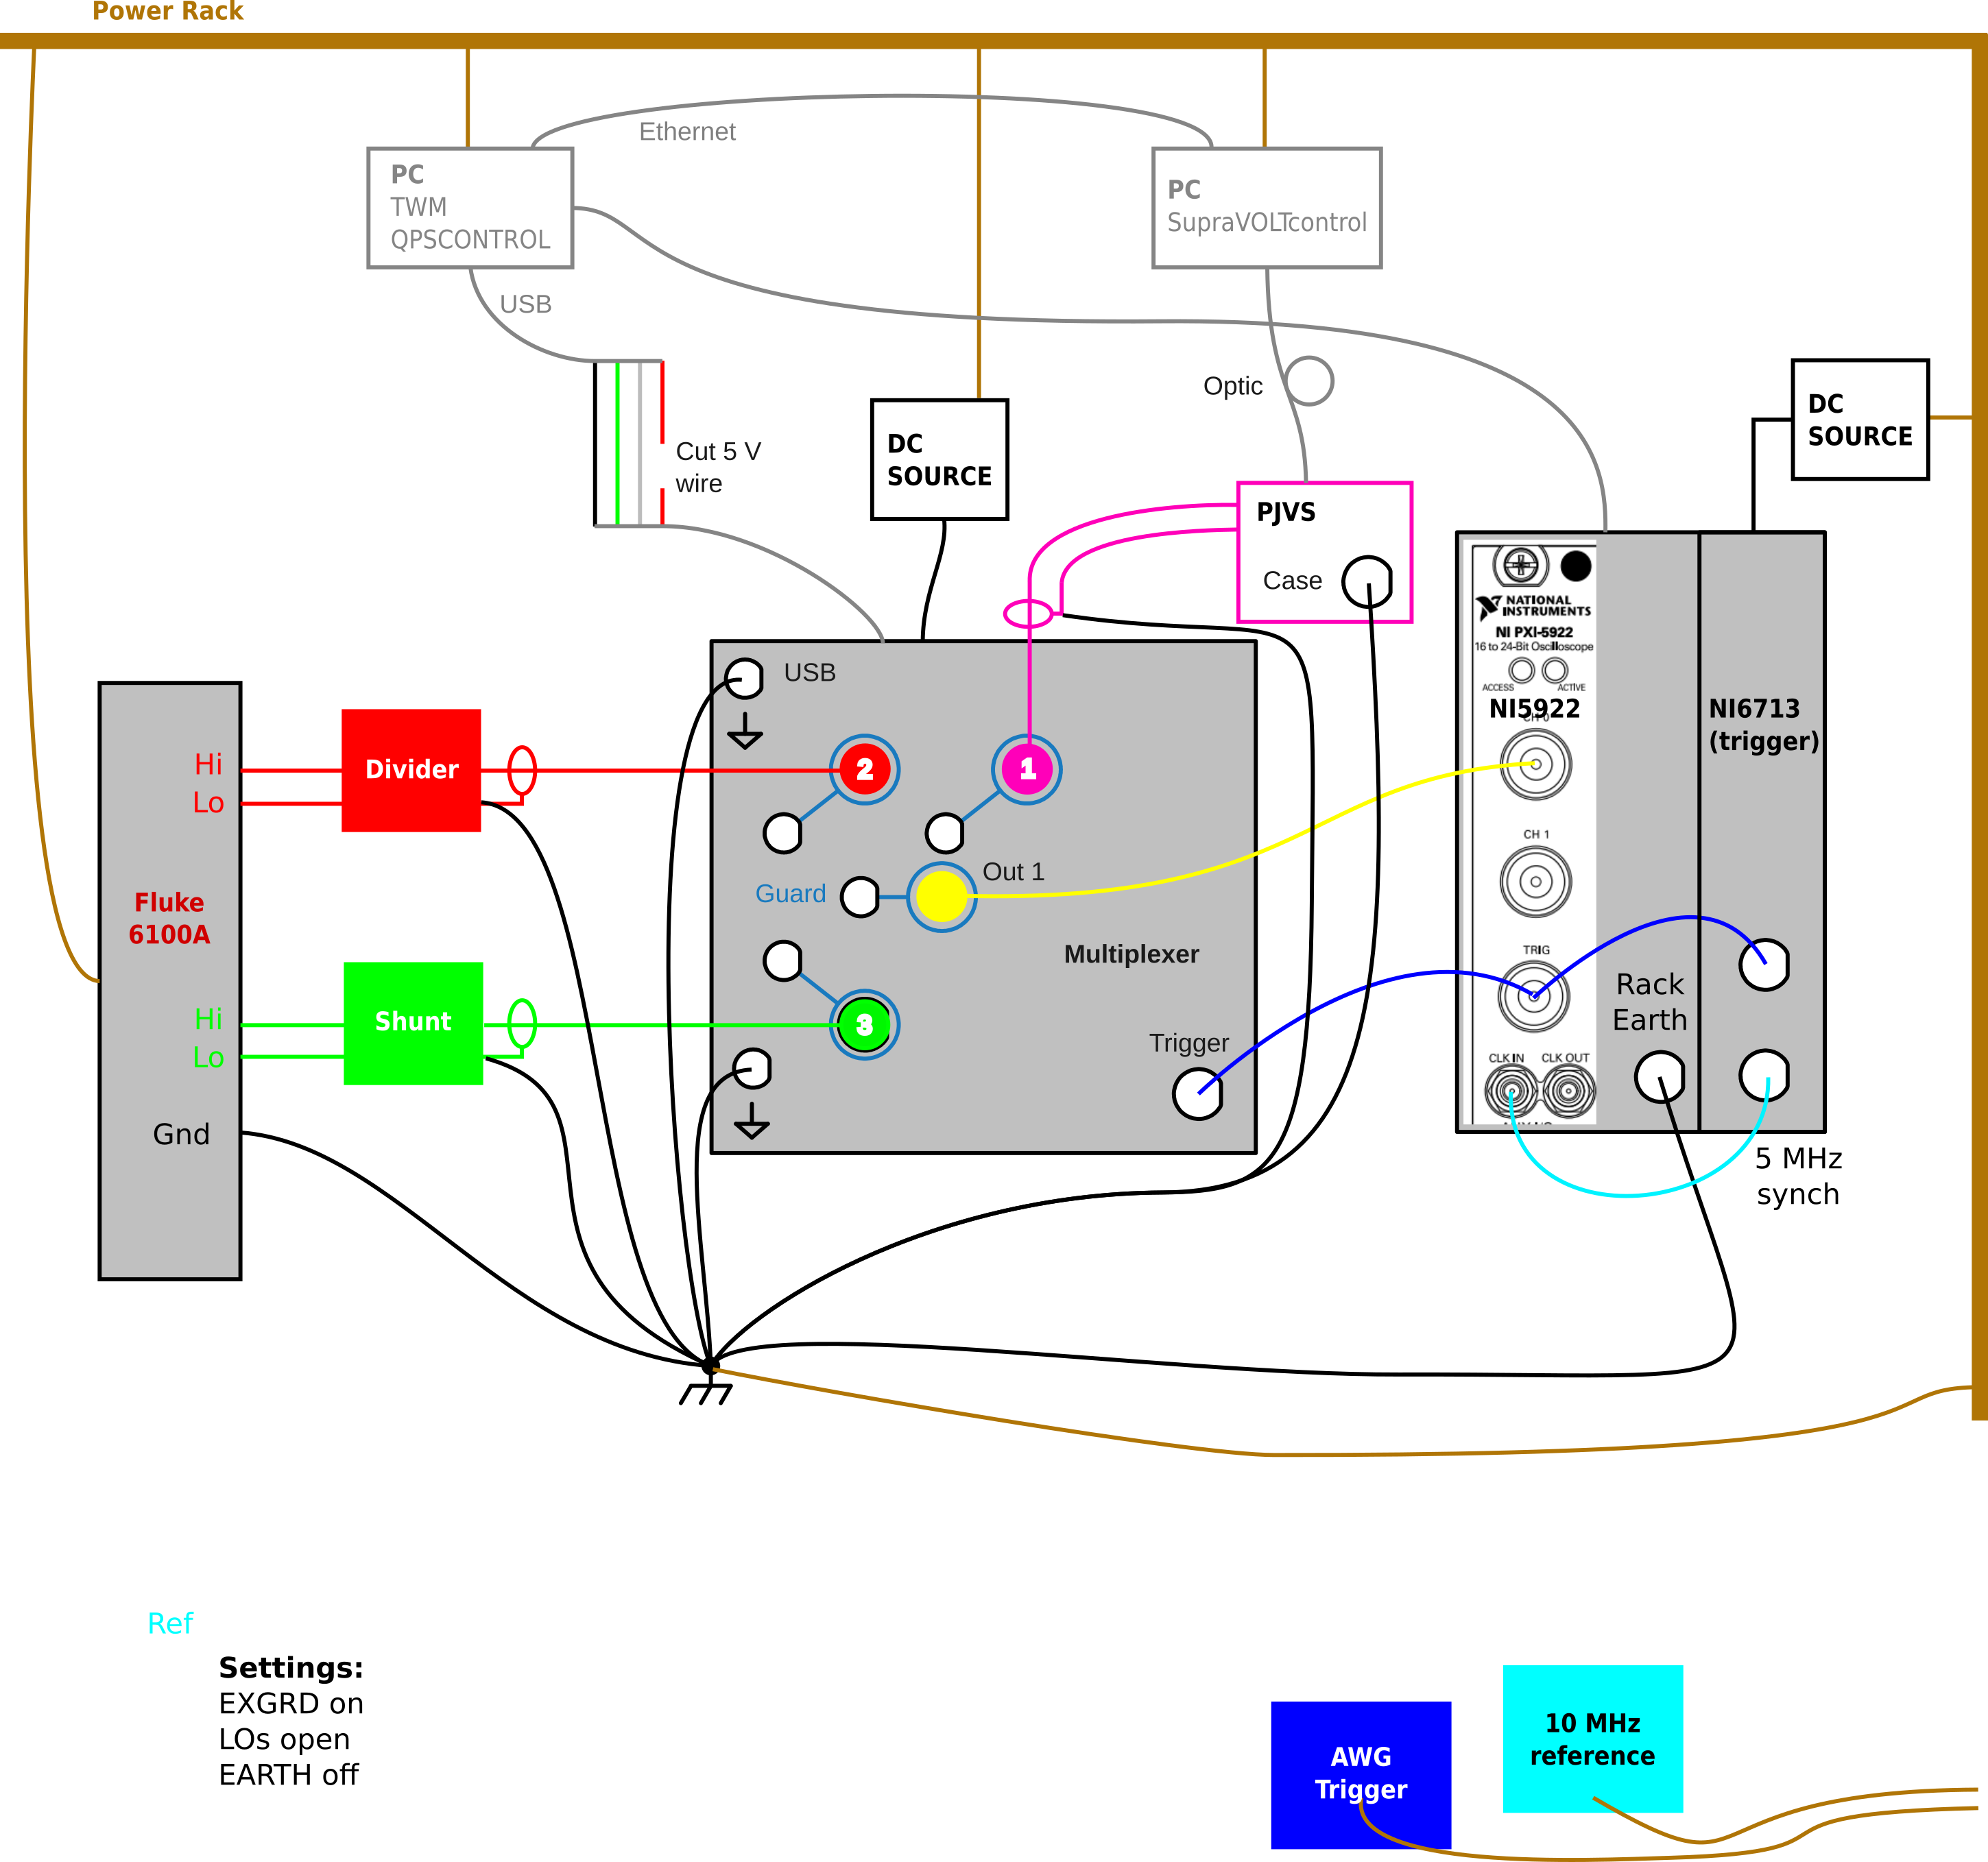

Measurement workflow
Power source: 240 V, 5 A, 60 Hz in the beginning for tests, later 53 Hz.
QPSCONTROL: scenario 1 ADC, 1 PJVS, better one is 2 ADC 1 PJVS. Periods 12/12/12 for testing, for measurements is needed 12/102/102.

